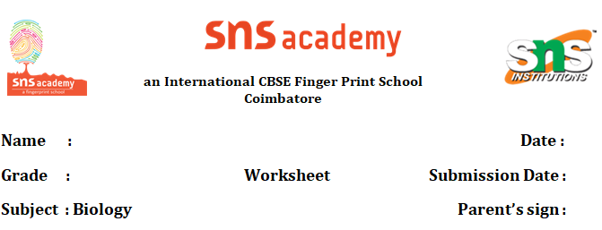

Nutrition in animals

# 1.In which part of the human digestive system digestion doesn't take place.

# A) Stomach B) Small Intestine C) Oesophagus D) Large Intestine

# 2. A locomotory organ found in unicellular animal-

# A) Cilia B) flagella C) Sessile D) Pseudopodia

# 3. DIRECTIONS: Match Column-I with Column-II and select the correct answer using the codes given below the columns.

| Column I | Column II |
| --- | --- |
| 1. Small intestine | p) 7.5 cm |
| 1. Large intestine | q) 1.5 cm |
| 1. Buccal cavity | r) Part of alimentary canal |
| 1. Ingestion | s) Process of taking food into the body |

# 

# A) (A) → (p), (B) → (q), (C) → (r), (D) → (s)

# B) (A) → (q), (B) → (p), (C) → (r), (D) → (s)

# C) (A) → (p), (B) → (q), (C) → (s), (D) → (r)

# D) (A) → (q), (B) → (p), (C) → (s), (D) → (r)

# 4.Select the one who first discovered one-celled animals

# A) Charaka B) Anton Leeuwenhoek

# C) Marcello Malpighi D) Galen

5. Ingestion is

# A) the mode of chewing and cutting food in mouth.

# B) the process of taking food into the body.

# C) both the above are correct. D) none of these is correct.

# 6. Assertion (A): Digestion of carbohydrates, like starch, begins in buccal cavity.

# Reason (R): The digested food is absorbed in the blood vessels from small

# intestines.

# A) Both A and R are true and R is the correct explanation of A.

# B) Both A and R are true but R is not the correct explanation of A.

# C) A is true but R is false.

# D) A is false but R is true.

# 7. Which one is incorrect about the liver?

# A) It stores proteins and fats B) It removes and stores iron from dead red blood cells

# C) It purifies blood D) It helps in digestion by producing bile

# 8. Statement (i): Extracellular digestion takes place in small intestine

Statement (ii): Digestion does not take place in stomach

# A) Statement (i) is correct while statement (ii) is incorrect.

# B) Statement (ii) is correct while statement (i) is incorrect.

# C) Both statements are correct.

# D) Both statements are incorrect.

9.DIRECTIONS: Read the passage given below and answer the questions that follow. Passage - 2 We can easily see cows, buffaloes and other grass- eating animals chewing continuously even when they are not eating. In fact, such animals quickly swallow the grass and store it in a part of stomach called rumen. Here the food gets partially digested and is called cud. Later the cud returns to the mouth in small lumps and the animals chew it. How is food ingested by grass-eating animals?

# A) by chewing B) by siphoning C) by swallowing D) by sucking

10. A’ got her gall bladder removed surgically as she was diagnosed with stones in her gall bladder. After the surgery, she faced problems in digestion of certain food items when consumed in bulk. Can you tell which kind of food items would they be and why?

11. Look at the below picture and answer the given questions.

1. What is the organ that ‘I’ refers to?
2. Name the alphabet that points to the large intestine.
3. Write the alphabet which points to the organ that has villi for absorption of digested food.
4. Another name for the food pipe is.
5. Write the alphabet of the largest organ in the human body and name it.

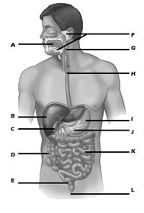

12. **Case Study: Rohan's Digestive Journey Questions**

Rohan, a Grade 7 student, is diligently studying the human digestive system for his upcoming science exam. He wants to understand the intricate process his body undergoes after he eats a meal, for instance, a simple slice of bread with some cheese. He is curious about how the complex food components are broken down, where the nutrients go, and what happens to the parts his body can't use. He's also trying to grasp the differences between physical and chemical changes in digestion and the roles of various organs within the alimentary canal.

**Questions:**

1. Rohan learns that food needs to be broken down into simpler substances. What is this overall process called?
2. After Rohan chews and swallows his food, it travels down a long tube to his stomach. Describe what happens to the food inside the stomach, including what substances are mixed with it.
3. What is the work of the small intestine?
4. What is the primary function of the large intestine concerning the remaining food material, and what is the final step in removing the undigested solid waste from the body?
5. Rohan once observed his neighbor's cow chewing continuously even when it wasn't actively eating grass. What is the digestion process in the cow called?